**Hello,** this Wellbeing Newsletter is for you so please let us know anything you would like to see in future newsletters by emailing [**SchoolsWellbeing@kirklees.gov.uk** ](mailto:SchoolsWellbeing@kirklees.gov.uk%20%20)

**Movember is Men’s Health Awarness Month**

Responsible for thousands of moustaches on men’s faces. Aims to raise vital funds and awareness for men's health.

What can you do to support Movember?

**What can you do for Movember?**

**Why not organise an event to coincide with International Men’s Day?**

[Movember UK](https://uk.movember.com/)

[Mental health in the workplace](https://www.nhsemployers.org/articles/mental-health-workplace)

<https://uk.movember.com/>



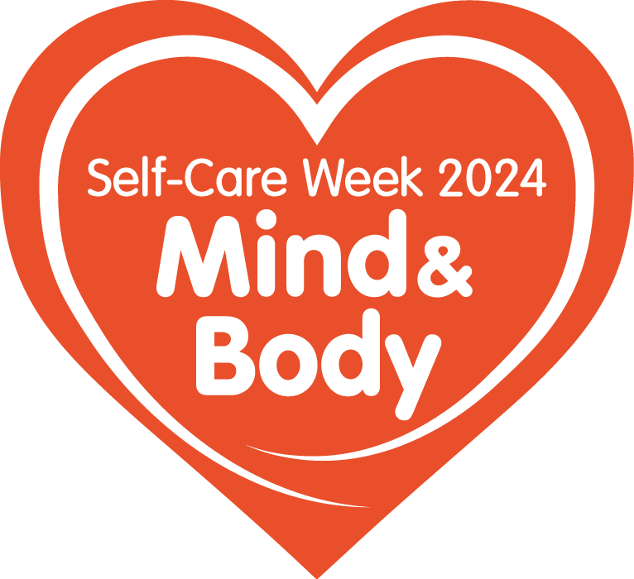**National Self-Care Week**

**18 - 24 November 2024**

**Mind & Body**

**What is National Self-Care Week?**

* Self-Care Week is an annual national awareness week that focuses on embedding support for self-care across communities, families and generations.
* The theme  is “Mind & Body”
* The Self Care Forum has been organising Self-Care Week since 2011

Click on this link to find out what you can do for National Self-care Week

<https://www.selfcareforum.org/events/self-care-week/>



International Stress Awareness Week attracts media attention and interest worldwide and, in 2024, ISMA’s 50th anniversary year, International Stress Awareness Week will be held between 4th – 8th November.

Click the link below for a Toolkit from Health and Safety Executive for the Education sector.

<https://www.hse.gov.uk/stress/assets/docs/talking-toolkit-education.pdf>





**Kirklees Council maintained schools are invited to**

**'Vivup your life' with access to a huge range of benefits.**

Vivup is an employee benefit scheme, that has loads of instant offers you’ll be able to access. With people struggling with the cost of living, the scheme could help with lots of things food shopping, electricals and DIY.

It's really quick and easy to sign up to and it's completely free! You can even download the app to your mobile to access your account and take advantage of the benefits wherever you are. Sign up on the [Vivup website](https://kirklees.vivup.co.uk/) selecting your dedicated platform from the Organisations drop-down list.

**Teachers**: select **Kirklees Council – Teachers**

**School Support**: Select **Kirklees Council – Council employees.**

If you need help with registration, contact Vivup customer services on 01252 784540 or email [customersupport@vivup.co.uk](mailto:customersupport@vivup.co.uk).



[**Our Workplace Wellbeing**](https://kirklees.eopas.co.uk/GenohsisPortal/login.aspx?ReturnUrl=%2fGenohsisPortal%2fPortalMain.aspx) **is our self-referral portal.**

**Mini health MOTs**

**Smoking cessation**

**Menopause support sessions**

**Physiotherapy**

**Counselling**

**Please also take a look at our** [**Employee Health Care Resources page**](https://secure2.sla-online.co.uk/v3/Resources/PageSetup/13025) **on Business Solutions that is updated regularly with our newsletters and available CareFirst webinars.**



Thank you, wishing you good health and happiness!

